House and Furniture
1. Label the furniture items. Choose from the words given.
rug coffee table washing machine bed television lamp drying machine bookcase window bathtub door stool painting mirror chair fridge sofa washbasin desk stove armchair shower dressing table dishwasher

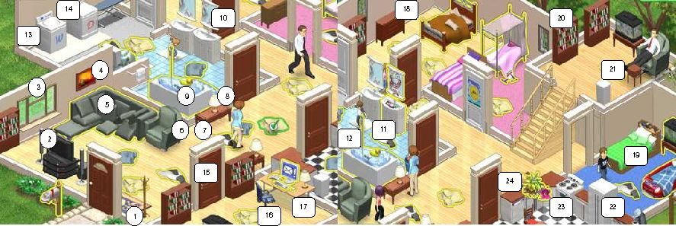
- _____________________________
- _____________________________
- _____________________________
- _____________________________
- _____________________________
- _____________________________
- _____________________________
- _____________________________
- _____________________________
- _____________________________
- _____________________________
- _____________________________
- _____________________________
- _____________________________
- _____________________________
- _____________________________
- _____________________________
- _____________________________
- _____________________________
- _____________________________
- _____________________________
- _____________________________
- _____________________________
- _____________________________

2. Read the text carefully and fill in the gaps with the names of the appropriate furniture items.
Today I woke up feeling great! I got up from 1__________ , put my feet on the 2__________ next to my bed and opened the window 3__________ to see what the weather was like. Then I went to the bathroom and got into the 4__________ to have a shower. After that I brushed my teeth in the 5__________ and went into my room again. I took some underwear out of the 6__________ and a sweater and a pair of jeans from the 7__________ . Mum was preparing breakfast when I went into the kitchen. It smelt delicious! I opened the 8__________ and picked up a cup from a shelf. Then I opened the 9__________ and took out a carton of milk. I put my cup of milk inside the 10__________ to get warm and used the 11__________ to make some pancakes. I like them with a lot of strawberry jam! I sat at the 12__________ to keep my mum some company and when I finished breakfast I put my dirty cup and plate inside the 13__________ . Before leaving home to meet my friends I looked at myself in the 14__________ to see if my hair was ok. Mum was putting some clothes to wash in the 15__________ and preparing to take some dry clothes out of the 16__________ . When I got home in the evening, I went into the living room and sat on the 17__________ to watch 18__________ . But there was nothing interesting on, so I took a book from the 19__________ and read for a while. I also picked an interesting magazine which was on the 20__________ in front of the sofa. As it was a bit cold, I lit the 21__________ to get more comfortable. After dinner I went to my bedroom and sat on a 22__________ in front of my 23__________ to do the homework. At half past ten I turned on the small 24__________ which is next to my bed on the 25__________ . Then I put my head on my __________ and went to sleep.

Answers
Exercise 1

- rug
- television
- window
- painting
- sofa
- armchair
- coffee table
- lamp
- bathtub
- mirror
- washbasin
- shower
- washing machine
- drying machine
- door
- chair
- desk
- dressing table
- bed
- bookcase
- stool
- fridge
- stove
- dishwasher

Exercise 2

- bed
- rug
- curtains
- bathtub
- washbasin
- dressing table
- wardrobe
- cupboard
- fridge
- microwave oven
- stove
- table
- dishwasher
- mirror
- washing machine
- drying machine
- sofa
- television
- bookcase
- coffee table
- fireplace
- chair
- desk
- lamp
- bedside table
- pillow

