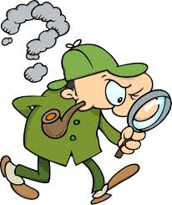**Where is Dumbo?**

**He is praying to god in …..**

**He is waiting for a train at the …….**

**He is entertaining himself in the …..**

**He is borrowing a book from the ….**

**He is watching some ships and boats in the ….**

**He is enjoying the performance in the …..**

**He is looking at some animals in the ….**

**He is afraid of heights but he is standing on the top of the …..**

**He wants to report a crime at the …..**

**He is buying some sports equipmentin the ….**

**He is going for a walk in the …**

**He is seriously ill, so he is staying in the …..**

**He is withdrawing some money from …..**

**He is drunk and he is leaning against the ….**

**He is watching the football match at the ……**

**He is getting married in ……**

**He is playing with other children in the …..**

**His wife kicked him out of the house, so he is spending the night in the ….**

**He is marvelling at the works of art in the ….**

**He is filling the car up at the …**

**He wants to rent a car, so he is going to the …**

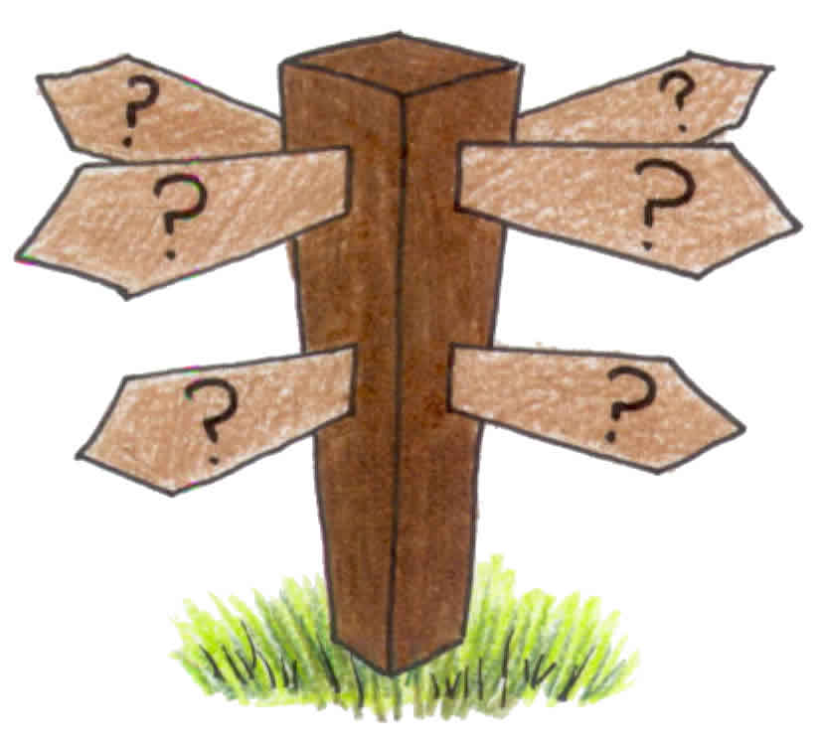

Reši spodnjo križanko in poskušaj ugotoviti ali je križanka v ameriški ali britanski angleščini. Poišči dokaze!

|  |  |  |
| --- | --- | --- |
|  | | **Down**  **2.** A home in the city.  city2b**3.** A place to study after high school.  **4.** A narrow street behind a building.  **5.** A very tall building.  **6.** What some people take to work.  **7.** Government official in charge of a city.  **8.** A place where people make things.  **9.** A place to go when you are sick.  **14.** A place on the sidewalk where you can put your mail.  **15.** ____________ lights. Lights that tell cars when to go or stop.  **18.** A traffic ___________. A time when traffic almost stops because there are too many cars on the road.  **20.** A time when many people are driving on the road to get to work.  **22.** A place where people walk next to the road.  **24.** A lot of people gathered together.  **25.** A road where people drive fast.  **28.** Cities have lots of these bright things at night.  **29.** Many people take this to work instead of their own car.  **30.** A place where people save their money.  **32.** A short sleep. |
| **Across**  **1.** A place to get something to eat.  **5.** An underground form of transportation.  **7.** A place with many shops in one building.  **10.** What you do on a bench.  **11.** A place where many business people work.  **12.** The opposite of no.  **13.** A place to see a show.  **16.** Go left or right. | **17.** A place to go for a walk.  **19.** A place to view art.  **21.** A place to learn history.  **23.** Many sounds.  **26.** Stealing or robbing.  **27.** Dirty air or dirty water.  **31.** Go ____. Enter.  **33.** A place where people park their cars.  **34.** What you do at a department store. |
|  | |

Rešitve za to križanko pa boste dobili v petek ;)

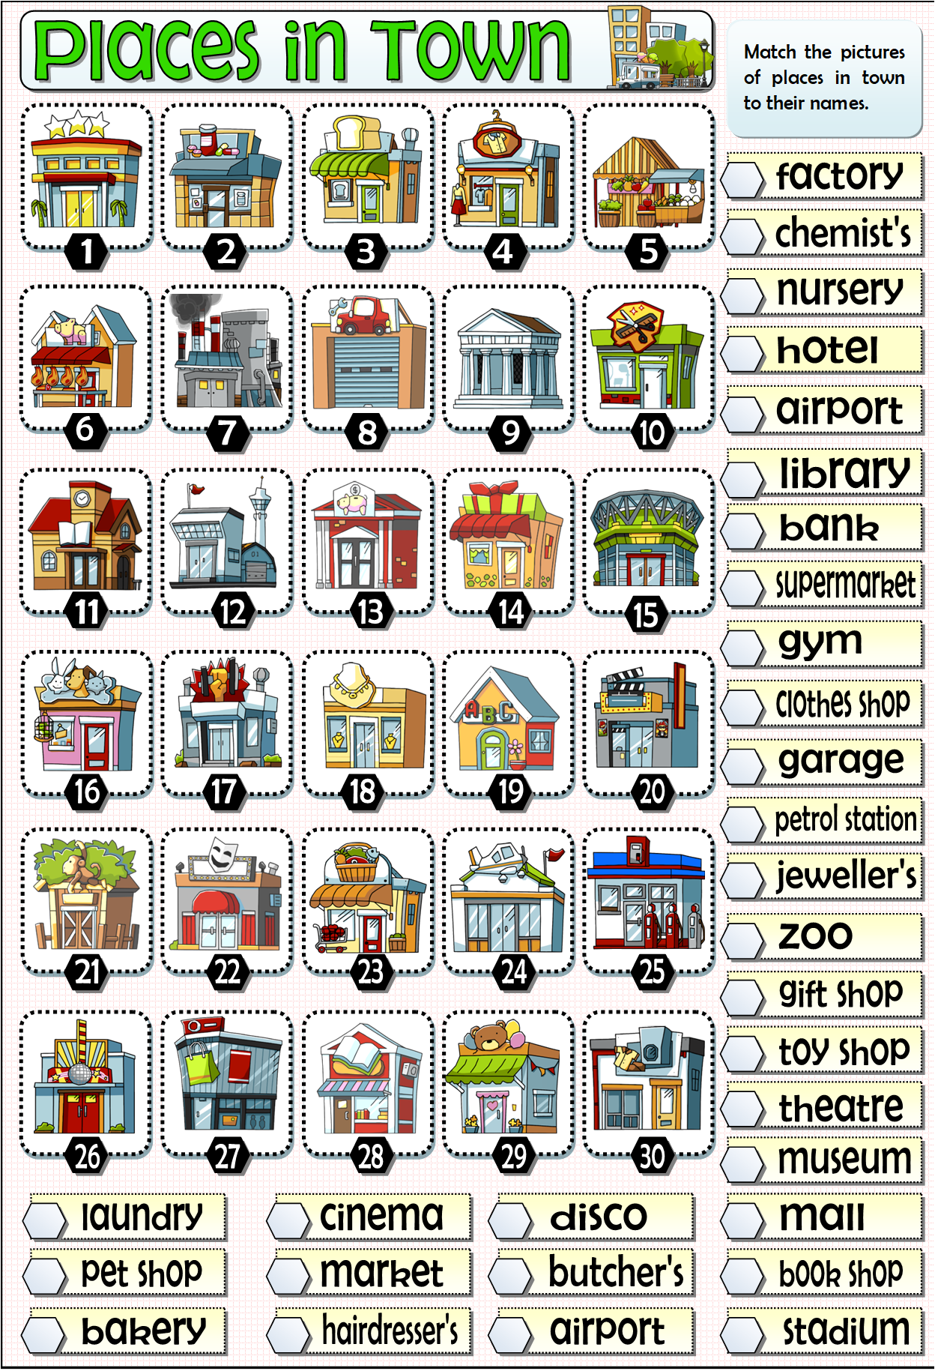

**KEY:**

**He is praying to god in a church / the cathedral.**

**He is waiting for a train at the railway station.**

**He is entertaining himself in the theme park / amusement park.**

**He is borrowing a book from the library.**

**He is watching some ships and boats in the harbour.**

**He is enjoying the performance in the theatre.**

**He is looking at some animals in the zoo.**

**He is afraid of heights but he is standing on the top of the …..skyscraper / tower.**

**He wants to report a crime at the police station.**

**He is buying some sports equipmentin the sports shop.**

**He is going for a walk in the park.**

**He is seriously ill, so he is staying in the hospital.**

**He is withdrawing some money from the ATM**

**He is drunk and he is leaning against the ….LAMPPOST / WALL.**

**He is watching the football match at the ……STADIUM / PUB**

**He is getting married in ……WEDDING CHAPEL / Town Hall.**

**He is playing with other children in the …..PLAYGROUND.**

**His wife kicked him out of the house, so he is spending the night in the ….HOTEL / MOTEL**

**He is marvelling at the works of art in the ART GALLERY.**

**He is filling the car up at the GAS STATION / PETROL STATION.**

**He wants to rent a car, so he is going to the CAR RENTAL (AGENCY).**