

Great Britain (2)

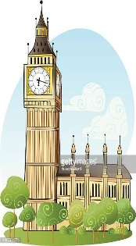**Read the words in the box below and then use them to answer the questions:**

|  |
| --- |
| Princess Diana prison cricket Vote red Buckingham Palace 99 sausages Bobby Union Jack polo kilt clock Primary Anne |

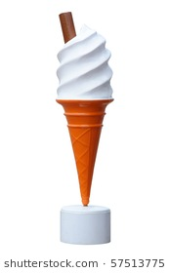

1. Name of the British flag. _____________
2. 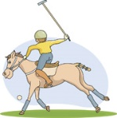Kind of school children attend at the age of 4-11. ______
3. Name of the Queen’s house in London. ___________
4. The sport prince Charles plays. ____________
5. 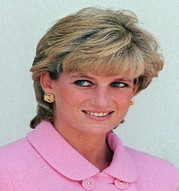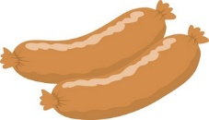The Queen can’t ___________
6. Colour of the famous London buses. ___________
7. Nickname for a British policeman. _________
8. 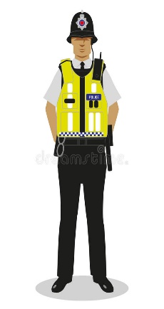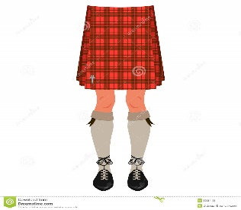Princess who died in 1997. _________
9. 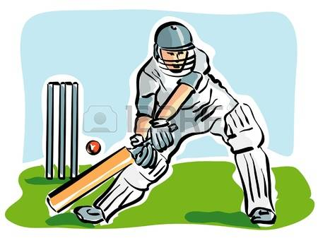National sport of England. _________
10. What are bangers? __________
11. Name of Queen’s daughter. __________
12. 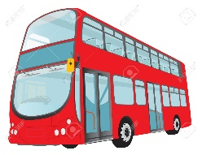Popular ice cream to eat in GB. _________
13. 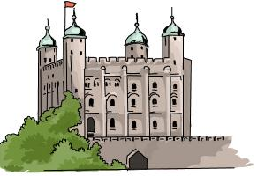The tower of London was a ____________
14. The Scottish wear skirts called ____________
15. Big Ben is a ______________