

Great Britain (4)

**Read the words in the box below and then use them to answer the questions:**

|  |
| --- |
| The Queen stamps The Beatles 1863 Passport Elizabeth Tower bulldog Tower Bridge Chicken Tikka Masala God Save the Queen  pillows lion police station Windsor Castle |

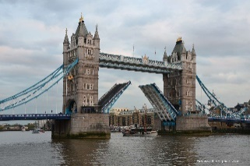

1. A famous British pop group. _____________
2. 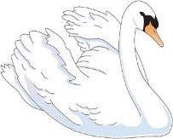The name of this famous bridge. ______
3. The London underground was open in _______
4. 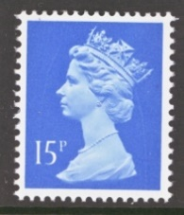All swans belong to the : ____________
5. 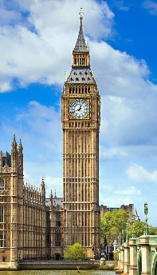The Queen doesn’t have a ___________
6. What is the name of this tower? ___________
7. Britain doesn’t have its name on its _________
8. The largest lived in castle in the world is _________
9. The Queen travels with her _________ and ________.
10. 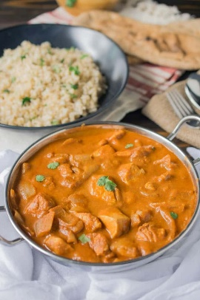What is the UK’s traditional dish? __________
11. Name of the UK’s anthem. __________
12. 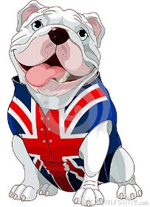National animals. _________ and ________
13. Buckingham Palace has its own ____________